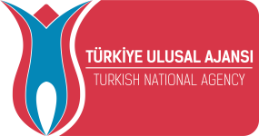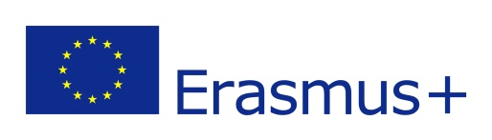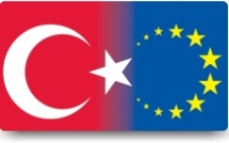

Project name : Look at the life from this side / Hayata Birde buradan bak
Activity status : Erasmus+ KA1 Youth Exchanges Programme
Project date: 17 - 24 February 2019, (Travel days 17-24 February 2019)
Country / City: Ankara – Turkey (Capital of Turkey)
Participants age: 15-30 age / no age limit for group leader
Each country: 6 participant + 1 group leader, total: 7 participant.
Project Referance Number: 2018-1-TR01-KA105-057434
Participants: Turkey, Poland, Croatia, Italy, Slovakia, Spain

Project Details;
“Look at the life from this side” project is a youth exchange which is made by Gazi Farkindalik Toplulugu. The project will deal with the rights and freedoms, needs and proposals of disadvantageous people, their participation in social and economic life as the content, will enable the evaluation of projects and activities carried out for disadvantageous people on the international scene. In the project, countries and organizations will cooperate like Slovakia: Youthfully Yours SR, Turkey: Gazi Farkindalik Toplulugu, Poland: Stowarzyszenie "Nasz Lag-nasza wies", Spain: Asociación Juvenil Almenaras (AJA), Croatia: Perpetuum, Italy: Associazione Let's Keep Learning Onlus. Each country will join in the project with 7 participants. The coordinator team will bring 8 participants in the project. Total number of participants of the project is 43. The project will also include individuals with Down syndrome, companions and people with limited opportunities. If possible participating countries can participate in the project with 2 down syndrome and 2 comrades individuals. So, we can contribute to them with project. Project planned to be held in Ankara/ Turkey between 17-24 February 2019.
“Look at the life from this side”, project is a project that aims to make an impact on the target groups as well as the participants. The project has been strengthened by the impact of the Erasmus + program on beneficiary groups. In this context, the project has additional goals like besides the activities to be carried out with disadvatageous individuals, communications and dialogues between generations and cultures, cooperation with youth workers and organizations, affects of the non-formal education methods on teaching and learning, introducing and dissemination of Erasmus+ program, the inclusion of the disadvantaged people to the social and cultural life, sharing experience and competencies, raising awareness and contributing to the formation of a more responsive society.
The project will be carried out using formal and non-formal learning methods. In this way, it is aimed to increase the participation rate of the participants in the project. The project will be implemented using the common language, English. In this way participants are expected to improve their English proficiency. In the project, seminars, presentations and open sessions, promotional activities for the partner organizations, promotional process of Erasmus+, Youthpass and Europass awareness studies to draw attention to limited and disabled people, group and team works for creating solution-oriented alternatives and sharing experience, cultural nights for intercultural interaction, recognition and dissemination for official institutions and press studies, communication and dialogue process with local people and social media works will take place.

Project Venue; ANKARA / TURKEY
Ankara; is the capital of Turkey and the country’s second-largest city. Ankara city is an important tourism center of the Anatolia Region It was formerly called Angora. Ankara is a cosmopolitan city with impressive public buildings, wide avenues, parks, an opera, and an international airport. The city is the site of the University of Ankara, founded in 1946, and of the British Institute of Archaeology, opened in 1948. Today, there are several universities in Ankara.

History: Known to the ancients as Ancyra, the city was from the 200’s b.c. the capital of Galatia, which, after 25 b.c., was a Roman province. The city was occupied successively by the Persians, Arabs, Seljuk Turks, and Crusaders. In the 1360’s it was captured by the Ottoman Turks. Sultan Bajazet I was defeated in the area in 1402 by Tamerlane, the Mongol conqueror. Recovered by the Turks in 1431, the city remained part of the Ottoman empire until the empire’s collapse after World War I. There are many historical places, and we will introduce to the participants. :)

Some photos and infos about the Ankara city;
1. https://en.wikipedia.org/wiki/Ankara
2. https://www.youtube.com/watch?v=Iikj33v-Q4w
For more information, our FB group; https://www.facebook.com/groups/1576420539126720

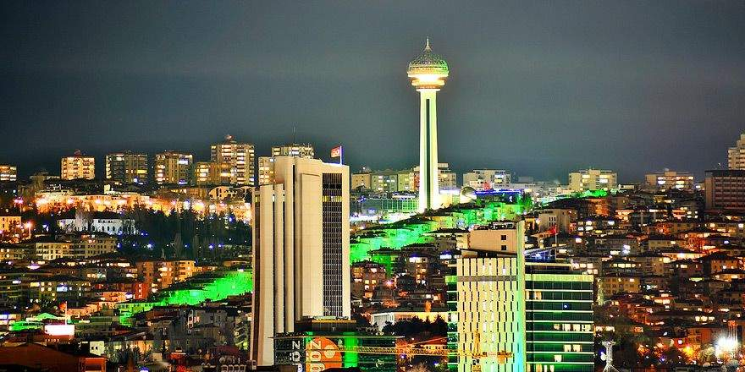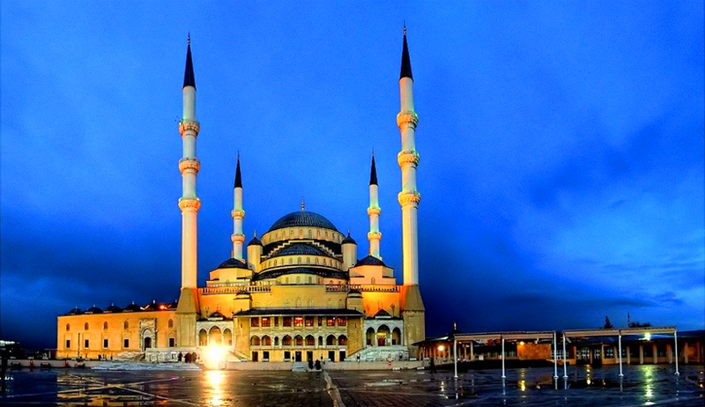

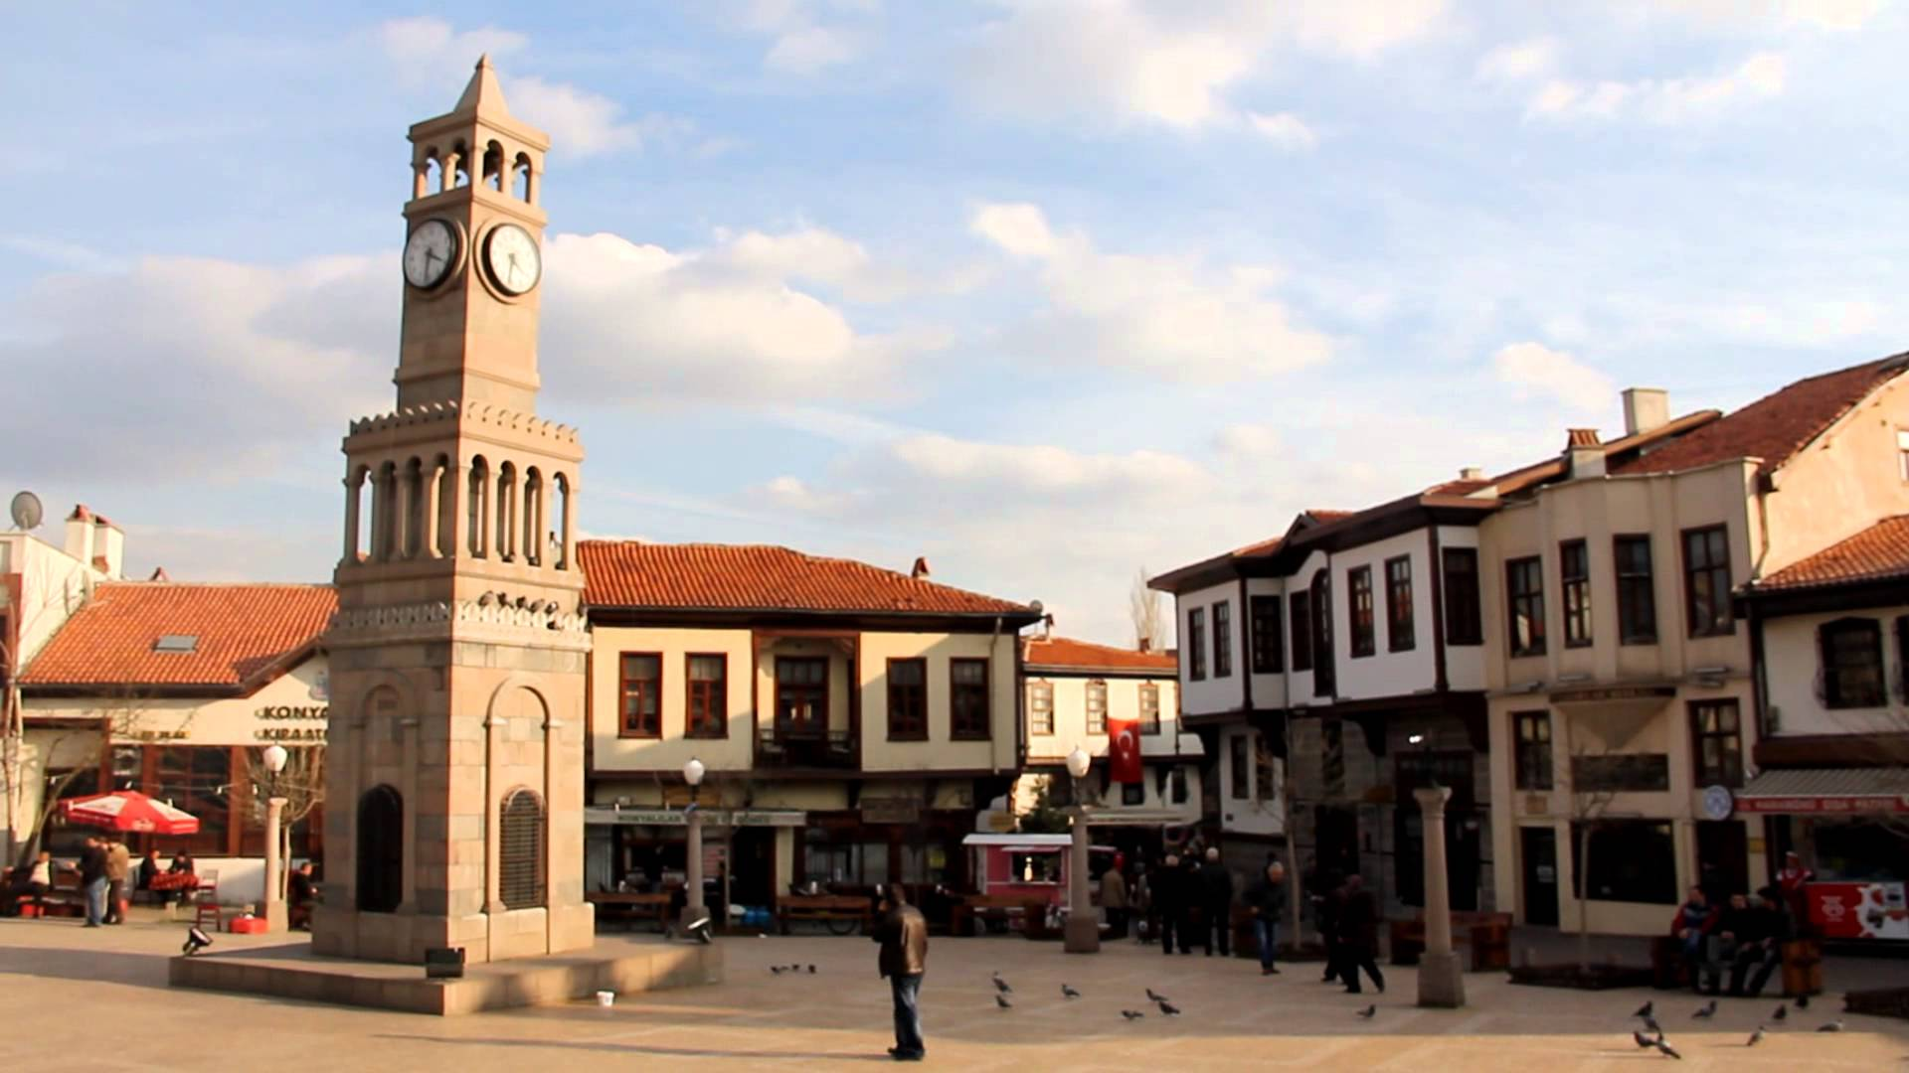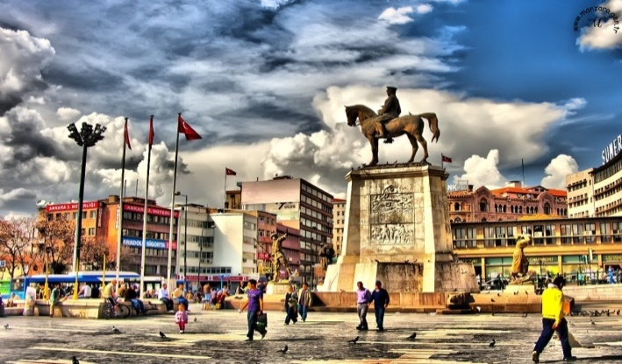

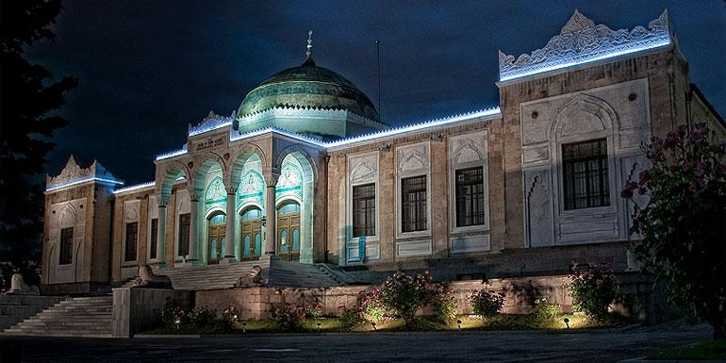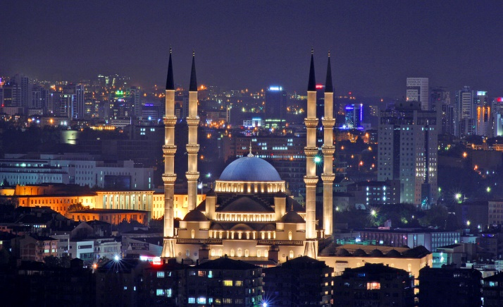

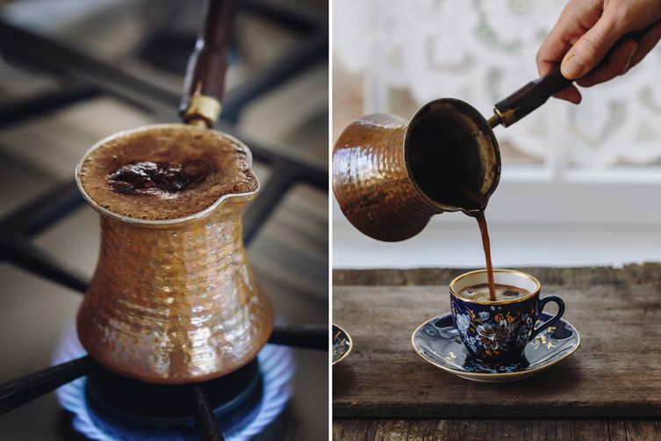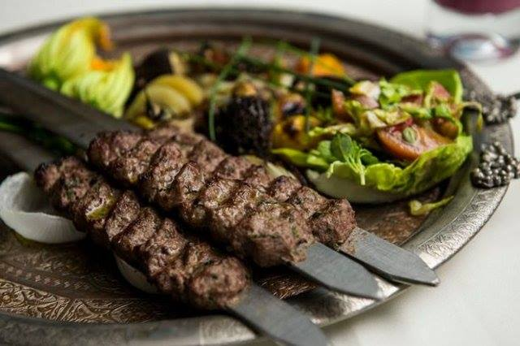

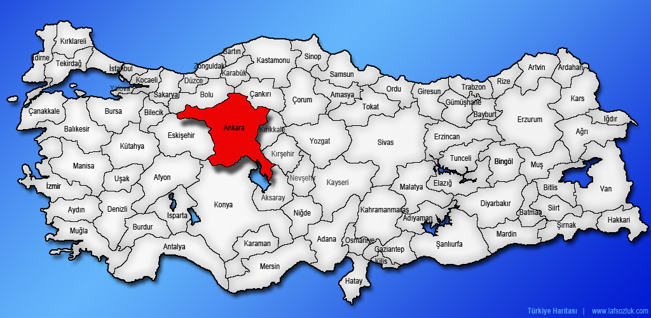

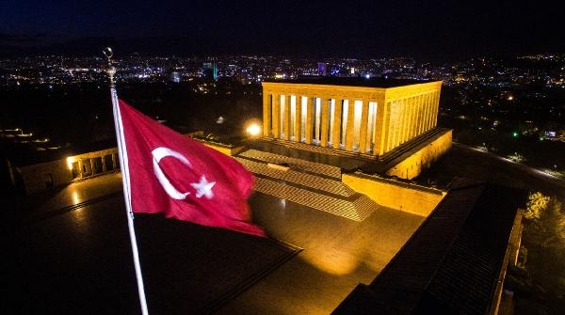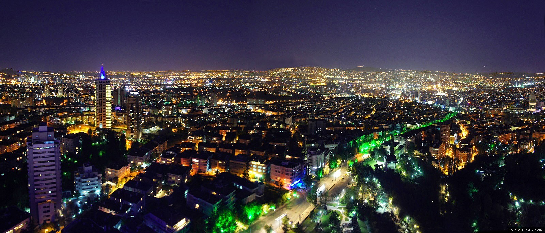

Participation to the project;

Each partner organization will send 7 participants (6 participants and 1 group leader). Selection of participants will be partners responsibility. Participants age: 15-30 age / no age limit for leaders.

IMPORTANT: Please let us know your participants names and information until 01 January 2019. (you can find this document in the attachment.)Participants must buy tickets until 15 January 2019 at the latest. Dear partners and participants; Please be sensitive on this matter, because the time will not be extended. Participants have to buy tickets from economy class. Travel costs in the city is included in the general travel costs. So try to find the cheapest ticket. please ask me for my confirmation before buying tickets. When you buy flight ticket, please send us your tickets copies.
Our project mail; gazifarkindaliktoplulugu@gmail.com

Accommodation;

The accommodation place was not finalized yet. So, you will receive another info pack later. Accommodation will be in the Ankara city center.
FINANCIAL – Travel and Visa Cost

Participants of the project will be reimbursed their travel expenses according to below table and visa cost. Organizers will provide accommodation and food during the whole period of the project. so, accommodation and food costs is free.

Corresponding submission of travel tickets, refunds will be made during the main project activities time. All boarding cards and electronic ticket must be present to us in hard copy. Only buses, trains, flight costs are paid. Here below you can see the table for maximum travel costs.

Country | Poland | Croatia | Italy | Spain | Slovakia
%100 MAX travel cost for each participant | 275 € | 275 € | 275 € | 360 € | 275 €

- If participants spend more than the calculation of the Distance Calculator, it will be participants responsibility to pay the rest of the traveling cost.

- Early arrivals or late departures will be the own responsibility of the participants. According to Turkish NA the travel back must be realized by participants on direct way within maximum of 4 days. This will be enough for you :)

- We need your all receipts, tickets and boarding passes (for both ways). So when you are coming, keep them. After the project you should send us (scanned by email and originals by post) all the tickets and boarding passes of the travel back home from Turkey. Participants have to buy tickets from economy class. Travel costs in the city is included in the general travel costs. So try to find the cheapest ticket.

Visa Costs: - We will cover VISA expenses for Polish and Spanish group (14 euro per person ). For this, please, the Polish and Spanish participants have to send to us as soon as possible a copy of their passports and the group’s list so that we prepare your Invitation letter in order to apply for your VISA. Participants must bring the originals of the visa documents to the project.

Youthpass Certificates
All participants receive Youthpass certificates. Youthpass is a part of the European Commission’s strategy to foster the recognition of non-formal learning. It is available for projects funded by Erasmus+: Youth in Action (2014-2020) As a tool to document and recognise learning outcomes, it puts policy into practice and practice into policy:
- While creating their Youthpass Certificate together with a support person, the participants of the projects have the possibility to describe what they have done in their project and which competences they have acquired. Thus, Youthpass supports the reflection upon the personal non-formal learning process and outcomes.
- Being a Europe-wide validation instrument for non-formal learning in the youth field, Youthpass contributes to strengthening the social recognition of youth work.
- Describing the added value of the project, Youthpass supports active European citizenship of young people and of youth workers. - Youthpass also aims at supporting the employability of young people and of youth workers by documenting the acquisition of key competences on a certificate.

NOTE:
• The Project will be carried out in TURKEY / ANKARA. (Capital of Turkey)
• We will provide you during the activities internet, too.
• Please if you have notebook (laptop), Tablet PC. etc please bring it for use on project.(Optional)
• We will meet you from the bus station. Please do not have any hesitation on this matter.
• As you know, there will be a intercultural night. We advise you take with you something special to your country and city, such as traditional clothes, foods or drinks.
• Please activate your phone for calls abroad.
• You can find exchange office in all airport. Please take Turkish money for transportation etc. Average 1 euro = 6.5 Turkish lira
• As you know and depending on the decision taken by European Commission all the expenses for foods and accommodation will be paid by us.
• Allow the participants to travel together. please, buy plane tickets on the same flight. (It is strongly recommended).
• Please remember to bring your personal belongings. ( towels, slippers, clothes etc)
• All of the participants must bring their boarding cards, bus tickets, train tickets and such like papers completely and orderly to make easy the payback. All original tickets and boardingpases (train, plane, bus etc.) must be to bring .
• Project working language will be English, for communications please prefer the people competent in English
• This is our facebook group https://www.facebook.com/groups/1576420539126720 please add all the participants. thus we can meet before the project.
How you can reach to Ankara City ?
Some Flight companies:
http://www.turkishairlines.com
http://www.flypgs.com
http://www.andolujet.com/
http://www.onurair.com.tr/
http://www.atlasjet.com

Some Bus Companies:
https://www.metroturizm.com.tr/en/
https://istanbulseyahat.com.tr/
https://www.kamilkoc.com.tr
https://www.obilet.com/

You can reach Ankara by the following ways;

1.WAY ( ANKARA AIRPORT / CAPITAL OF TURKEY)
1. Participants will buy flight tickets for ANKARA CITY.
2. The participants will go to the ANKARA bus station from the airport
3. And we will meet you at the Ankara bus station (AŞTİ).
How will you reach to Ankara bus station (Aşti)?
When you arrive to Ankara airport you will get on public bus in front of the gate. Bus name: BELKO AIR or HAVAS, On the bus written: HAVAALANI-AŞTİ (BUS STATİON) -KIZILAY. Each 30 minutes bus is leaving from Airport to Bus station (AŞTİ). Bus color is: white. You will pay to bus 15 TL. You can buy your ticket in Bus- Don’t lose your ticket for reimbursement. You will get off at AŞTİ bus stop. Don’t forget to tell bus driver you will get off in AŞTİ. It will take about 30- 45 minutes from Airport to AŞTİ (Bus station).
2 .WAY ( ISTANBUL AIRPORT); (for more cheaper tickets)
The average time between Istanbul and Ankara is 5 hours by the bus. You can find cheap flights for Istanbul airport. For this reason, you may come to Ankara from Istanbul. There are 2 different airports in Istanbul. ( Sabiha Gökçen Airport and Ataturk Airport ). So, if you want to come to Ankara from Istanbul;
1. Participants will buy flight tickets for İstanbul.
2. The participants will go to the bus station from the airport.
3. Participants will buy bus ticket for Ankara, and we will meet you at the Ankara bus station.
(You can find always bus from Istanbul Bus station.) bus price average: 60 TL ( 9 euro )
- If you come to the airport Atatürk Airport (Recommended for Istanbul) ; Very easy to come the bus station to the from airport. There is have a metro station in the airport. and metro it will bring you directly to the bus station. ( this bus station name; Esenler Bus Station)
- If you come to the airport Sabiha Gokcen; When you artirived sabiha Gökçen airport you will take bus which is name HAVATAŞ you will get of in KADIKÖY. From KADIKÖY to HAREM OTOGAR (BUS STATION) you take a taxi or you can use small local bus to artşve HAREM OTOGAR. From HAREM you can take take a bus. But you should be faster to reach busses. İn istanbul trafic a big mass. You also may get further information at the airport advisory. ( this bus station name; Harem Bus Station)
NOTE:
To find cheap tickets (please buy tickets early) When you come in the bus station, please let us know. As you know, we will meet you in bus station (AŞTİ). And also, Please do not forget, participants must buy tickets until 15 January 2019 at the latest.

You can reach us with following numbers.
Mr. Burak Ortaç: +90 536 849 30 19
Mr. Yasir Çavent: +90 554 380 99 44
Mr. Yalçın Yılmaz: +90 542 679 80 10

Coordinator team: Gazi Farkindalik Toplulugu
Mr. Yalçın YILMAZ, Project Coordinator
Coordinator fb; https://www.facebook.com/yalcinyilmaz.tr
Project group fb; https://www.facebook.com/groups/1576420539126720
Project mail address; gazifarkindaliktoplulugu@gmail.com
Regards from Ankara/TURKEY

Project partner organizations and contact addresses:
Turkey  Coordinator | Gazi Farkindalik Toplulugu | gazifarkindaliktoplulugu@gmail.com  https://www.facebook.com/yalcinyilmaz.tr  https://www.facebook.com/groups/1576420539126720
Poland | Stowarzyszenie “Nasz Lag-nasza wies” | http://stowlag.org.pl/  biuro@stowlag.org.pl
Croatia | Perpetuum | https://www.facebook.com/udrugaperpetuum  udrugaperpetuum@gmail.com
Slovakia | Youthfully Yours SR | http://youthfullyyours.sk  info@youthfullyyours.sk
Italy | Associazione Let's Keep Learning Onlus | www.associazionelkl.it  info@associazionelkl.it
Spain | Asociación Juvenil Almenaras | http://asociacionalmenaras.com  info@asociacionalmenaras.com

if you have any questions don't hesitate to ask
PROJECT TIME

