PARTICIPANTS GUIDE
Writing E+ can be achievable
Training Course 25th April – 5th May 2018, Larnaca, Cyprus
The Training Course is funded by the European Union under the frame of Erasmus+
A significant number of project applications under the frame of Erasmus+ are submitted every year to the National Agencies aiming at fostering among others youth mobility within Europe, developing competencies of youth and addressing various needs and challenges that youth face nowadays. Examining the topic themes of those projects as they are publicly announced and promoted on various online sources, as well as observing their implementation phase if you are a participant, one can sensibly ask the question whether these youth projects are in fact written by youth (i.e. youth workers, youth leaders, young people) or not. The answer is indeed disappointing as, according to surveys within NGOs, youth can hardly prepare and write an Erasmus+ project for different reasons which include among other the following: they have little or no knowledge regarding the project application (e.g. the different sections that comprise the application), they have difficulty in understanding key words of the application (e.g. dissemination, impact, visibility), they have a misconception regarding the language they need to use in the completion of the application, they have difficulties identifying the needs of their youth community and engage youth in the actual writing of the project.
The Training Course “Writing E+ can be achievable” aims to give the opportunity to young people to experience the fascinating magic behind the writing of Erasmus+ projects and break down the stereotype according to which the preparation and writing of such a project is a significantly difficult and time consuming task. The Training Course aims to bring together 7 European NGOs and 28 young people who share the desire to improve or gain their knowledge regarding the writing of Erasmus+ projects.

By the end of the Training Course, the participants will:
- Acquire and improve their knowledge regarding the preparation and writing of an Erasmus+ project as well as gain practical training regarding the questions of the proposal; they will additionally understand complex concepts such as impact, dissemination and visibility of the project
- Develop their skills that will enable them to identify the needs and problems of young people in their community and then involve them in the preparation and writing of the project
- Develop their self-confidence which is needed in order (a) to realize that they are capable of writing an Erasmus+ project and (b) to face and overcome failure in case the project is not approved; they will then be more motivated to write projects and involve young people in the process
- Build partnerships in order to collaborate in the writing and submission of Erasmus+ projects and thus utilize the skills and knowledge gained in the TC; we are expecting a minimum of 3 projects to be submitted in the next 6 months after the project based on partnerships started in this TC

Partnership
Cyprus: IDRYMA ERGODOTISIS EKPEDEFSIS NEOLEAS (IEEN) (Andreas Andreou andreou.forensiclinguist@gmail.com)
Czech Republic: Find Your Nation (Lenka Unzeitigová Unzeitigova.Le@gmail.com)
Slovakia: YOUTHFULLY YOURS SR (Eva Kuráňová kuranova@youthfullyyours.sk)
Spain: ASOCIACION VIAJE A LA SOSTENIBILIDAD (Carlos Buj carlos@viajealasostenibilidad.org)
Malta: Active Youth (Alphonse Zammit alphzamm@onvol.net)
Lithuania: Mano Europa (Ruta Vaitekūnaitė ruta.ruteles@gmail.com)
Croatia: Udruga mladih PHARINA (Jurica Peric jurica.petric@gmail.com)

- What you need to know:
Participants: 4 pax/country, 2 girls and 2 guys, Youth workers, Youth leaders, Youth with no or very limited experience in writing Erasmus+ applications
Age Group: Over 18!!!
Language: The working language will be English

- Arrival and departure
You are expected to arrive on the 25th of April at the Larnaca International Airport or Pafos Airport as the seminar starts with common dinner and a getting to know each other session, after dinner. The departure will be on the 5th of May.
Do not book any flights to and from the Turkish occupied area of Cyprus (e.g. Ercan airport) as the Republic of Cyprus has no authority to access that area in case something goes wrong during your arrival/departure!

- What to bring
We kindly ask you to bring:
- Clear information (in English) about the main activities of your organization so that you can present it at the organizations bazar during the training course.
- Map, posters, postcards about your country/region/town to be displayed during the International Evening.
- Some gastronomic specialties (food and/or drinks) for the International Evening.
- Swimwear: As the weather is expected to be between 15°C (during the night) – 25°C (during the day), you shouldn’t miss the chance to swim in the clear, blue water of Makenzie beach (Blue Flag). The hotel also has also a roof pool.
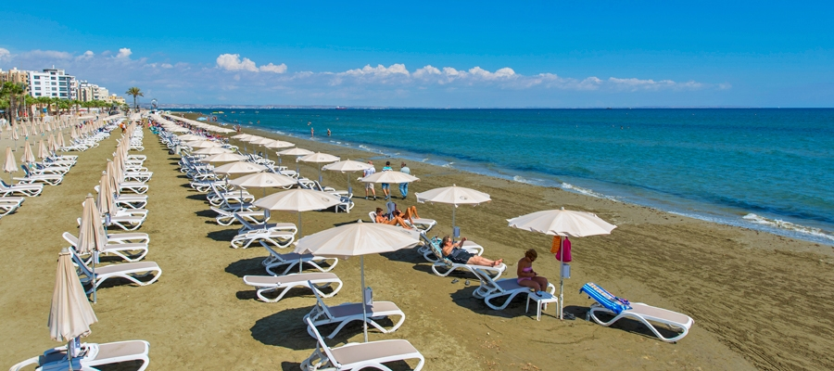

- Venue and accommodation
The training course takes place at the Flamingo Beach Hotel which is located just 8 km from the Larnaca International Airport (https://flamingohotelcyprus.com/)

Address
152, Piale Pasha Avenue
6028 Larnaca - Cyprus
P: +357 24828208

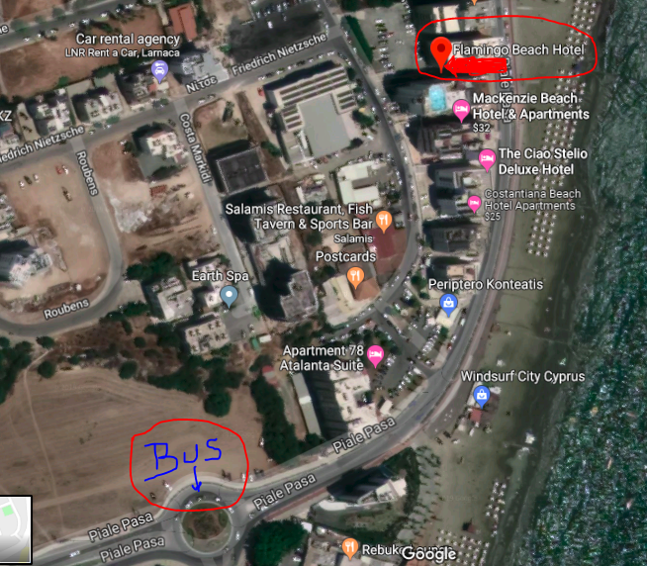

You will be accommodated in triple and double rooms with shower and toilet. Bed linen will be provided as well as towels. However, bring your own towels to use for the beach and the pool. We won’t put people from same nationality in rooms in order to give you the chance to learn about new cultures.
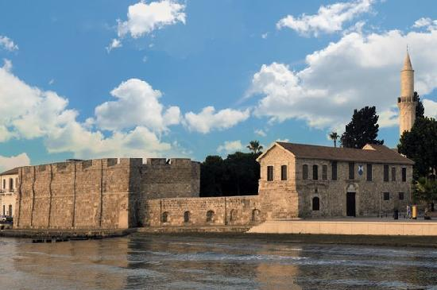

How to get to the Hotel:
Bus no 425 from Larnaca International Airport
(http://www.zinonasbuses.com/admin/uploads/pdfs/pdf234.pdf, http://www.zinonasbuses.com/)
The bus stop at Larnaca airport is found just outside the airport building. There are signs as soon as you leave the baggage claim areas which guide you to the bus stop. You should catch the bus 425 and ask the driver to stop at Makentzy which is basically the first bus stop after the Airport. The hotel is just 2mins walking distance from the bus stop. (take a look at the map above). The bus ticket costs between 1.50 euro (one way during the day) and 2.50 (one way during the night).

- Meals
We will have a thematic buffet every day that will include different dishes from the local and international cuisine. Please tell us if you have any special request (diet, vegetarian diet, health regime) to inform the hotel staff to provide for you special food.

- Costs / travel expenses and reimbursement
There is no registration fee. Accommodation, food and refreshments are covered by the project.
The participants will be reimbursed for their travel expenses TO and FROM LARNACA according to the Erasmus+ funding rules. Reimbursement amount per country:
Croatia 275 euros/participant
Lithuania 360 euros/participant
Malta 275 euros/participant
Slovakia 275 euros/participant
Spain 530 euros/participant
Czech Republic 360 euros/participant

Keep in mind, that if you buy your ticket in your local currency, we will calculate your travel costs according to the exchange rates from official European Commission web site.
Each Group Leader is committed to collect the return tickets and invoices from the participants and send the originals to the coordinator in a week after their departure. Participants will receive the reimbursement of their travel costs once the hosting organization receives the first payment by the National Agency of Cyprus. In particular, travel expenses will be reimbursed by our organization directly to our partner organization from each country. The reimbursement will be done through bank transfer to the accounts of the group leaders of each organization. For this reason, the group leaders are kindly requested to provide on time the coordinator with their bank account number.
Keep ALL the tickets, boarding passes and invoices in order to get reimbursed.

- Youthpass
Within the frame of ‘recognition of non-formal learning’, participants will receive a “Youthpass” Certificate after the course upon their request. Youthpass is an official recognized tool in order to validate non-formal learning aspects gained during the training. Through the process of receiving a Youthpass Certificate, participants will also gather information and methodologies how to implement Youthpass in their own projects. It is important that, before coming to the training course, participants reflect upon what competences they aim to develop by taking the initiative to participate at the training course. For further information, just follow the link: http://www.youthpass.eu
We are looking forward to meeting all of you and having great time in Larnaca!
If you need further information, please don’t hesitate to contact me: andreou.forensiclinguist@gmail.com
https://www.facebook.com/andreas.andreou.1800
+35799438562
Andreas Andreou – Project Coordinator

P.S. We also have a Facebook group (https://www.facebook.com/groups/574909636321597/)

