Version 0.0
1/2020
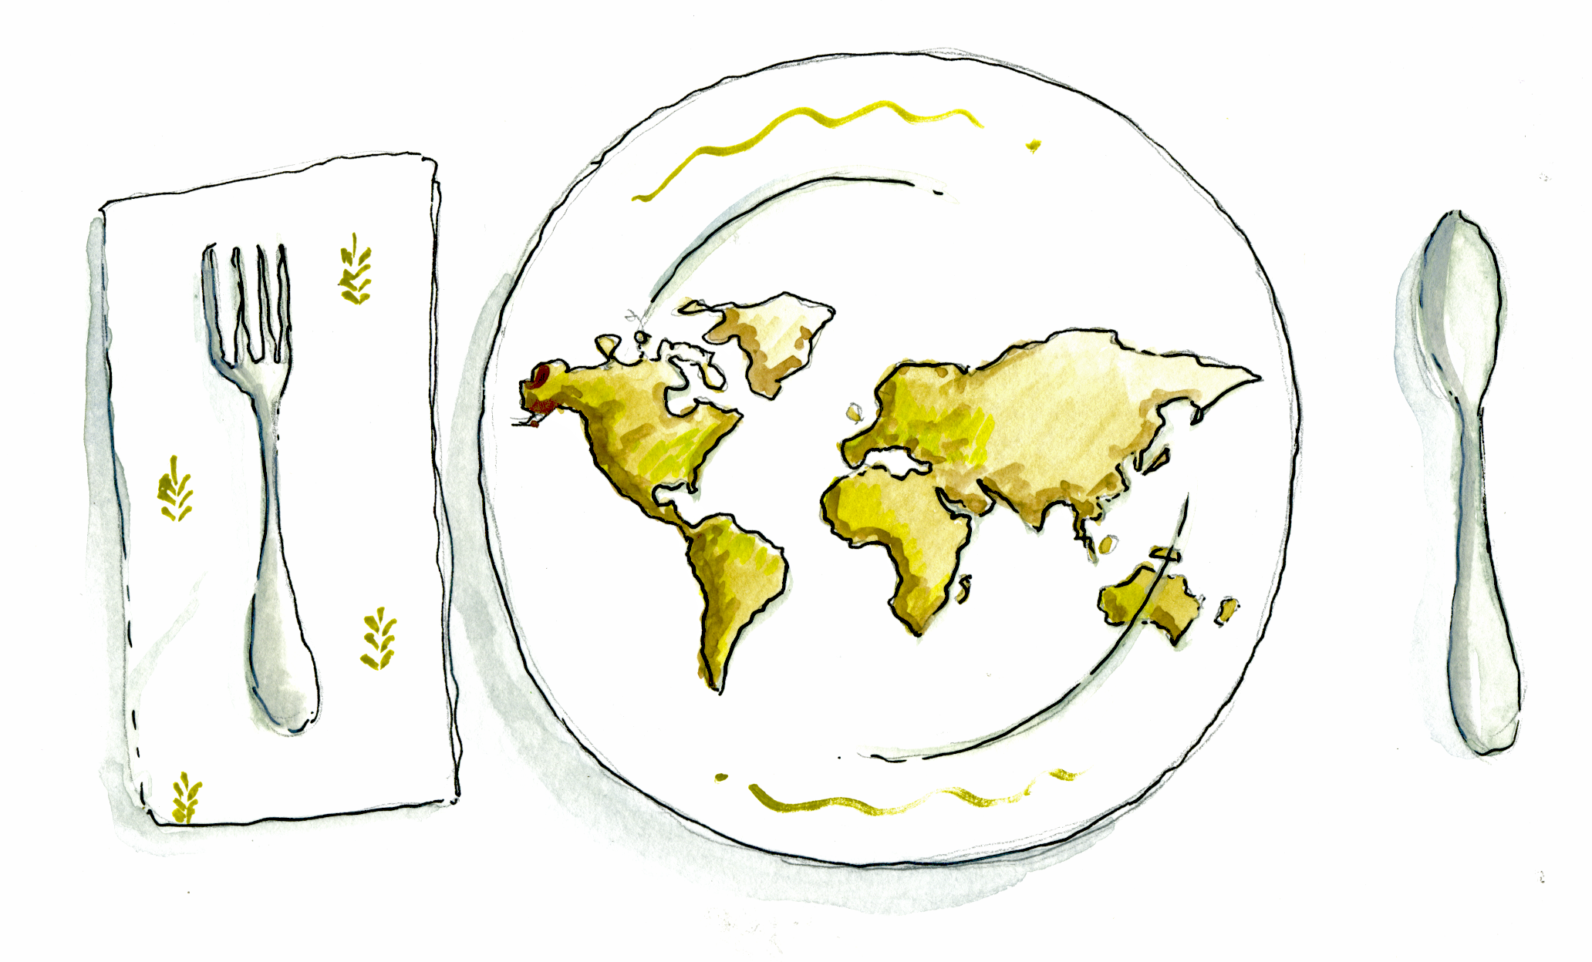

YOUTH EXCHANGE “COOLINARY YOUTH“
[30.03. – 05.04.2020., Samobor, croatia]
UDRUŽENJE OBRTNIKA SAMOBORA, SVETE NEDELJE I STUPNIKA
ŠMIDHENOVA 34, SAMOBOR
UO.SAMOBOR@HOK.HR

YOUTH EXCHANGE “COOLINARY YOUTH“

The project „Coolinary Youth“ was developed by a group of young people and enthusiasts who are actively engaged in promoting cultural heritage and creative gastronomy culture in local communities of partner organizations. Every participating country has a different gastronomy culture and cuisine diversity. Although countries have cultural differences we strongly believe that nothing brings young people together like sharing food and culture. Especially in nowdays, with lots of fast food available and whole new cuisinies, young people often set aside their basic gastronomy culture. Therefore the goal of this Project is to raise, trough non-formal education, the awareness and understending about different gastronomy culture and cultural cuisine diversity of young people with fewer opportunities in order to help them appreciate identity and cooporate valuing each others differences.

Specific project objectives are:

- increasing knowledge and motivation about the topic of different gastronomy and cusinie cultures,
- raising awareness of participants with different approaches to gastronomy and to support their creativity and different views of gastronomy and cultural heritage
- increasing and encouraging creative expression of the participants through process of creating easy and simple recipes for „Coolinary Youth“ brochure that promotes culture and cuisine of each participating country and in making creative cake installations,
- developing intercultural and language competences of the participants, especially the ability to work in intercultural teams, to overcome cultural prejudices and build mutual tolerance,
- increasing knowledge about Erasmus + and youth mobility and
- creating „Coolinary Youth“ brochure with various easy and simple cooking recipes from each participants country.

PROJECT DURATION: 01.02.2020. – 30.06.2020.

Arrival date and time: March 29th 2020, 6:00 pm
Departure date and time: April 6th 2020, 10:00 am

youth exchange overview
Category | Data
Name of the project: | Coolinary Youth
Type: | Erasmus+ KA1, Youth Exchange
Dates of main activity: | 30.03. – 05.04.2020.
Project venue: | Samobor, Croatia
Number of participants: | 6 participants per country (5 young people + 1 group leader)
Age limit: | 18-30 (20-30 for group leaders)
Participating countries | Croatia, Spain, Slovakia, Italy and Turkey

timetable

 | Day 1 | Day 2 | Day 3 | Day 4 | Day 5 | Day 6 | Day 7 | Day 8 | Day 9
9.00 – 10.00 | ARRIVALS | BREAKFAST
10.00 – 11.30 |  | Getting to know each other / EFC | Cultures & Gastronomy | Coolinary Youth – introduction & visit to local farmers market | Practical workshop | Practical workshop – creating brochure | Practical workshop – creating cake installations | Final public event |  | DEPARTURES
11.30 – 12.00 |  | COFFEE BREAK
12.00 – 13.30 |  | Introduction to project topic | Gastro You(th) – What can I do? | Practical workshop | Practical workshop | Practical workshop– creating brochure | Practical workshop – creating cake installations
13.30 – 15.00 |  | LUNCH
15.00 – 16.30 |  | Teambuilding & Rules | Pastry making – similarities and differences | Practical workshop | Local traditional craft food – visit to local craftsmen | Practical workshop– creating brochure | Practical workshop – creating cake installations | Final reflection
16.30 – 17.00 |  | COFFEE BREAK
17.00 – 18.30 |  | Erasmus+ Programme | Creative gastronomy – traditional crafting | Practical workshop | Local traditional craft food – visit to local craftsmen | Practical workshop– creating brochure | Practical workshop – creating cake installations | Evaluation
18.30 – 19.00 |  | REFLECTION
19.00 | DINNER
21.00 |  | Intercultural night |  |  |  |  |  | Farewell evening

methods and activities
This project is based on the methods of non-formal education, which support active involvement of participants and focus on their self-reflection and documentation of learning outcomes. Such methods also encourage young people to choose their own approaches and methods that offer them the flexibility and freedom to explore their emerging interests.

theoretical workshops
Theoretical part of the main activity, based on the methods of non-formal education, non-hierarchical approach and implemented by participants themselves (through research, simulations, presentations, discussions etc.) focuses on exploring topics of gastronomy cultural heritage and different national cuisines. Second part is focused on increasing participants knowledge and creativity through discuission of creative gastronomy and traditional cultural heritage of their countries.

practical workshops

Practical part of this project is focused on making and presenting one carachteristic national dish, producing „Coolinary Youth“ brochure with recepies and making of fake cake instalations. Practical workshops are based on cooking, drawing/painting, creating visual materials (graphic design of brochure, digital branding) and producing media content.

impact
This project is expected to impact the participants through achieving their learning goals as well as
developing specific set of skills and knowledge. It is expected that participants will develop wider
understanding of different cultures and gastronomy, knowledge about cultural similarities and
differences as well as new approaches within the areas of gastronomy and cultural heritage.

Furthermore, it is expected that they will increase their sense of awareness that cherishing cultures
and gastronomy is a great way of preservation of the identity, which will benefit primarily their local
communities.

PARTICIPANTS
Participants will be from following countries: Croatia, Italy, Spain, Slovakia and Turkey. There will be total number of 30 participants (5 + 1 group leader from each country). Participants should be between 18 and 30 years old. In each group there will be one group leader age 20-30, preferably a person who has already been to at least one or two YE.
Participants should have high interest in topics of gastronomy cultural heritage and cultural differences and want to share and learn more about new gastronomies and cuisines and through non-formal education develop practical skills in cooking and baking national/local dishes. Also, participants need to know basics of cooking and baking, for the activities in project include cooking/baking one national dish from participants country.
Preference is given to young people who come from rural areas in their countries, young people who face economic or geographic obstacles. Their profile is as follows:
1) Cultural differences -participants from this category are the ones having different cultural background. This project will enable them to gain theoretical and practical knowledge about different cultures, enabling them to understand gastronomy cultural differences better and provide activities on this topic, thereby disseminating the competences acquired.
2.) Geographical obstacles-advantage is given to young people coming from rural and undeveloped areas
3.) Economic obstacles – participants who come from families with lower financial incomes and don't have the same opportunities as their peers to take part in international projects and those who are unemployed or in a process of education.
Each organisation is responsible for sending a gender mixed team (3 female and 3 male participants), involving fewer opportunities participants as well. ALL participants will need to fulfill an application form and the Hosting organization must have this information from each participant:
- Full name,
- Gender,
- Date of birth and age,
- Place of birth,
- Passport, ID number with issue and expiration date,
- Phone number and email,
- Special needs/ allergies, Food restriction, Health restrictions.

The application form will be collected by partner organisations and it should be sent to the HO to uo.samobor@hok.hr.

The main language used during the YE will be English. Participants taking part in this project must be able to community and express themselves in English.

technical information

accommodation
Accommodation, living and other project / exchange related expenses are 100% founded by the EU. Participants will be provided with 3 meals per day and coffee breaks.
Participants will be accommodated in Hostel Samobor. There, they will be divided into two and four bed rooms. The rooms are equipped with bunk beds and the hostel also provides wireless internet connection. The laundry facilities, kitchen and air conditioned living room with 60 chairs and TV are located on the first floor.
Bed linen and towels are provided but we suggest participants also bring their own towels.
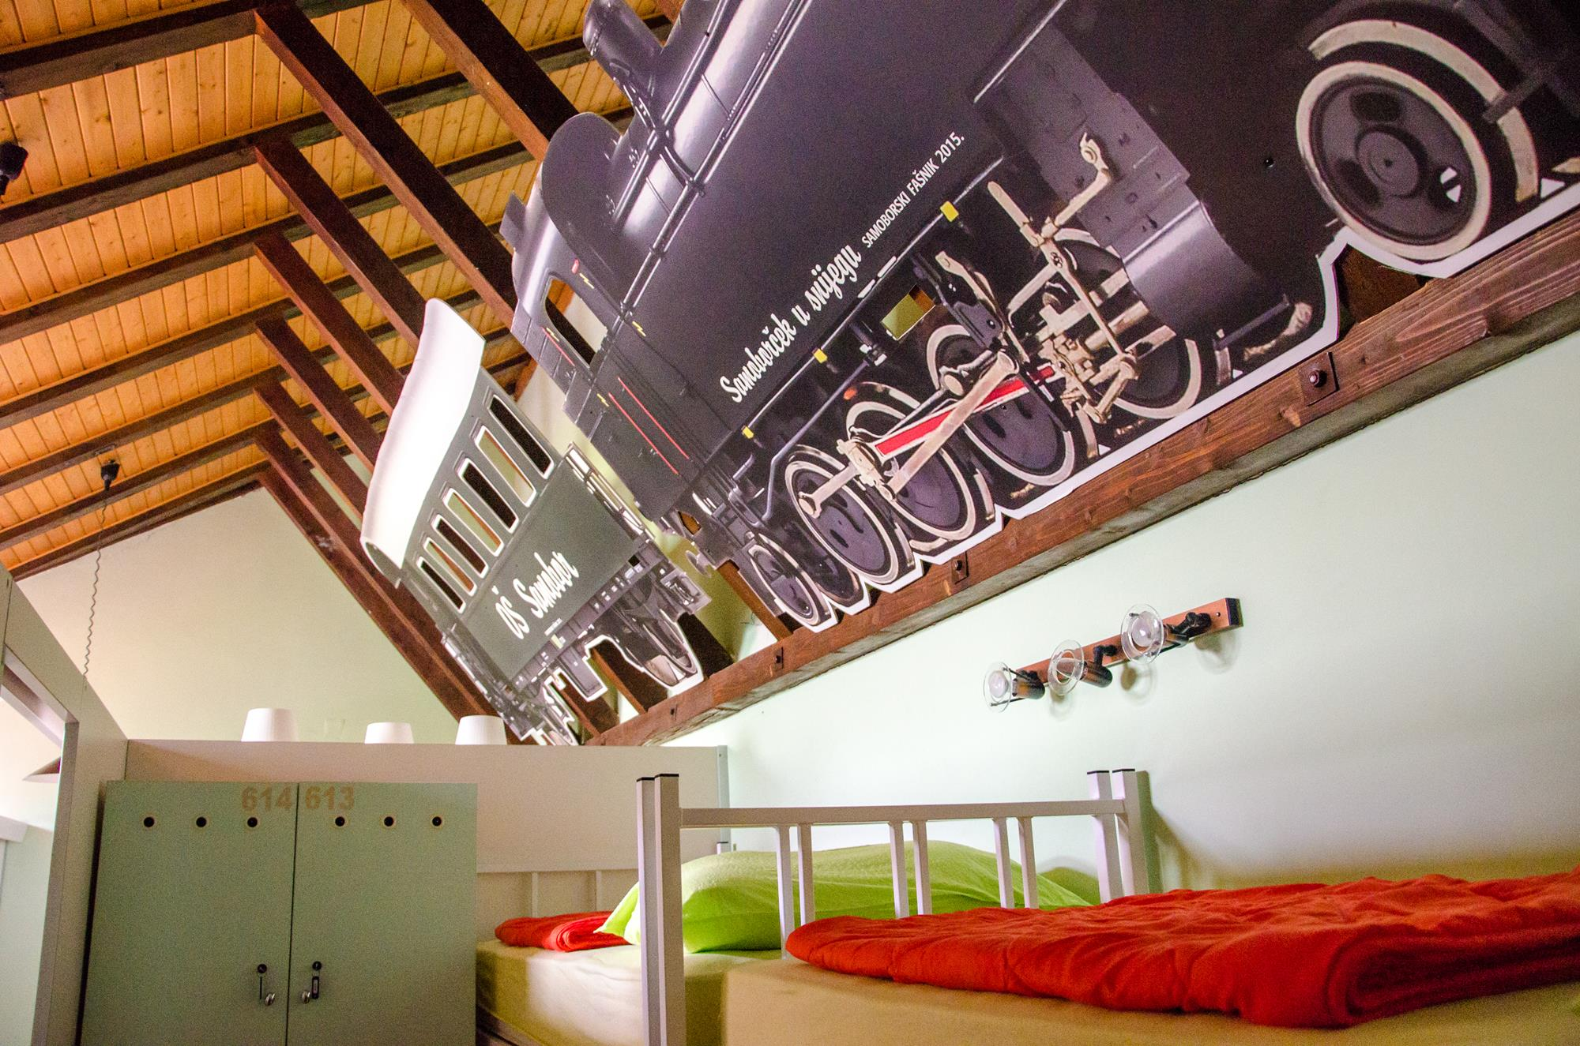
Hostel Samobor: http://www.hostel-samobor.hr/en/

travel
Travel expenses of the participants are covered in line with Erasmus+ Programme rules and European distance calculator. (https://ec.europa.eu/programmes/erasmus-plus/resources/distance-calculator_en)

Please keep originals of the travel tickets and boarding passes, as without such documents we will not be able to make the reimbursement.
Reimbursement of travel expenses for the participants will be carried out through bank transfers (to the account of sending organization) after the main activity, upon collecting all relevant documentation. Participant needs to send a travel plan to organizers before buying a ticket!
After the travel plan is approved by organizer, participant can start to buy the ticket that the organizers have approved.
Reimbursement framework:

COUNTRY | PARTICIPANTS | TRAVEL GRANT  (per participant) | TRAVEL GRANT  (organization) | TRAVEL DISTANCE*
Croatia | 6 | 0 € | 0 € | 0 - 99 km
Italy | 6 | 275 € | 1650 € | 500 – 1999 km
Slovakia | 6 | 275 € | 1650 € | 500 - 1999 km
Spain | 6 | 275 € | 1650 € | 500 -1999km
Turkey | 6 | 275 € | 1650 € | 500 - 1999 km

*Based on travel distance per participant (distance between place of departure and venue of the project). Distance should be calculated by using European Distance Calculator (https://ec.europa.eu/programmes/erasmus-plus/resources/distance-calculator_en) for each of the participants individually.
We kindly ask all of the participants to calculate their travel distance in advance (prior to buying tickets), as in case if they fall within lower travel distance (e.g. between 100 and 499 km) their travel limit is lower.
After calculating, please check the following table to determine your limit of travel costs:

DISTANCE | TRAVEL COSTS LIMIT
10 – 99 km | 20 EUR
100 – 499 km | 180 EUR
500 – 1999 km | 275 EUR
2000 – 2999 km | 360 EUR

Before buying any tickets, please consult us on uo.samobor@hok.hr

travel tips

FROM ZAGREB INTERNATIONAL AIRPORT (DR. FRANJO TUĐMAN) TO ZAGREB MAIN BUS STATION

The Zagreb airport Dr. Franjo Tuđman is situated 12 km from the city center of Zagreb; the airport is the largest in Croatia, with international connection to most of Europe and domestic connection to the major cities in Croatia.
The airport bus is parked outside the main arrival terminal. The trip with the airport bus to the main bus station takes about 35-40 minutes; at the main bus station, you also have tram connection to the city center. You can see departure times from Airport to bus station here: http://www.plesoprijevoz.hr/en/page/timetable

Please note that after 8 PM, buses depart from the airport after aircraft landing. Price for a one way ticket with the airport bus is 30 kuna (approximately 4 euros).

FROM ZAGREB MAIN BUS STATION TO SAMOBOR

Local bus from the main bus station to Samobor departures approximately every half an hour. The trip can last between 30 and 50 minutes, depending on whether it is a direct line.
Please note that you are supposed to buy tickets directly from the bus driver while entering the bus.
Price for a one way ticket is 28 kuna (approximately 4 euros).
You can see departure times from Zagreb bus station to Samobor here (155 – Samobor – Sveta Nedjelja – Zagreb (Autobusni kolodvor) under „JESENSKI VOZNI RED“).

TRANSPORT BY CAR

If you are arriving by car or organized transport via highway, also just follow the directions for Zagreb. When you arrive to Zagreb / near Zagreb you will have a bypass rim around Zagreb, use that, don't go in the city if you wish avoid traffic jams! When you are on the rim follow the signs towards Ljubljana – Slovenia, when you pass Zagreb you will shortly have an exit to Samobor and Sveta Nedelja. If you miss this exit, don't worry as there will be another one few kilometers forward. If you miss that also you will arrive to the toll place and after it border between Croatia and Slovenia. Then you will know that you have missed all exits, so you would need to turn around and watch closely for next exits.
When you arrive MEETING POINT will be on MAIN BUS STATION in SAMOBOR. There will be somebody from our team waiting for you.

VENUE

SAMOBOR

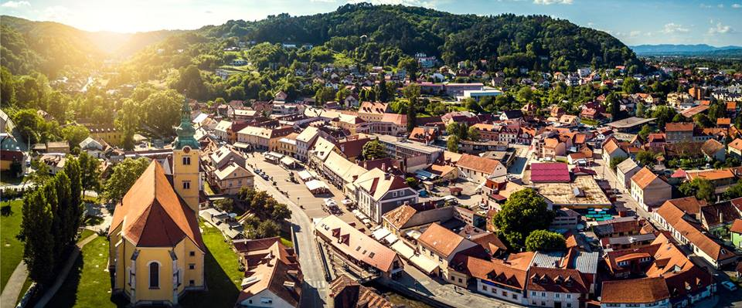

Samobor is a city in Zagreb County, Croatia. It is part of the Zagreb metropolitan area. Samobor is located west of Zagreb, between the eastern slopes of the Samobor hills, the eastern part of Žumberak Mountain, in the Sava river valley. It is part of the historical region of Croatia proper.

You will fall in love with magnificent walks through the city, discovering culture and history, but also as You leave the city and head to the forests and mountains. Fresh air, untouched nature, sunny vineyards, family restaurants offering cozy atmosphere and local cuisine are perfect invitation for spending time in Samobor. During the year, there are plenty of events You can visit, especially the Samobor Carnival („Fašnik“) that takes place in February, Battle of Samobor in 1441 in March, Samobor Spring Fair and Salami Festival usually in March/April, Circus festival in April/May or Samobor Music festival in September/October.

Also, you should not leave Samobor without trying some of the specialties from exquisite local cuisine, „bermet“ (aperitif wine), „češnofke“ (sausage), „kotlovina“ (meat prepared in cauldron), „kremšnita“ (famous custard pastries), „ Rudarska greblica“ (miners pie) or some of the local wines that you can try along the Wine road. For all information about Samobor, please visit official web site of Samobor.

practical information

don’t forget to bring!
- Personal medication;
- Identification documents (ID, passport, visa, etc.);
- Health/travel insurance;
- Old or spare clothing and shoes that you can wear for workshops such as cooking and making fake cake installations.
- 1 laptop per national team;
- Travel tickets and boarding passes (originals);
We strongly recommend every participant to acquire health/travel insurance at their own expense for the whole duration of the exchange.
Also, please get a valid EU healthcare insurance card (if applicable):
- if you're an EU citizen, you have the right on free health insurance that gives you access to medically necessary, state-provided healthcare;
- European Health Insurance Card info - http://ec.europa.eu/social/main.jsp?catId=559)

Official currency in Croatia is Croatian kuna.
1 euro = 7.45 kn
(InforEuro - http://ec.europa.eu/budget/contracts_grants/info_contracts/inforeuro/index_en.cfm)

in case of emergency
All important contact numbers and information on safety procedures will be placed in visible places at the project venue and introduced to participants at the beginning of the main project activity. Some of the most important telephone numbers in Croatia are listed below.
Risk prevention measures shaped in the form of questions and recommendations are part of the Information Package, Application form and Partner Agreement and refer to health insurance, travelling, intercultural and linguistic preparation, special food and medical requirements, etc.
(+385) 112 – emergency number
(+385) 192 – police
(+385) 193 – fire brigade
(+385) 194 – ambulance
(+385) 195 – search and rescue at the sea
(+385) 1987 – road assistance
(+385) 1 4640 800- HAK (Croatian automobile club)
(+385) 11888 – telephone directory
(+385) 18166 – weather forecast
(+385) 18981 – general information
(+385) 11802 – international telephone directory

preparation

task-related preparation
Task related preparation of the participants will be focused on researching national gastronomy and cultural cuisine diversity which will be used during practical workshops of the project, especially during making and preparing national dishes of each participants country. In preparatory fase of the project focus will also be on preparing participants for intercultural evenings.
During the YE each one will get the opportunity to present his/her own organization in a visual way during cultural nights and workshops. We encourage participants to bring as much relevant-materials as possible. Please bring with you:
• Information –in English! about your organization; brochures, leaflets, etc.
• All relevant information you have on the previous international project(s) you’ve organized / been part off (reports, gadgets and press releases).
• Picture, posters, etc.
information of your countries gastronomy and cultural heritage
some recipes of your countries national dishes and pastries

Intercultural Evening
Please bring something typical from your place: food, drinks, traditional clothes, music, any “strange stuff” to show, say us some curiosity about your traditions or social behaviors, teach us some dance, play a traditional game, everything but power point presentation and touristic videos from YouTube!

intercultural and linguistic preparation
Croatia (kroʊˈeɪʃə/ kroh-ay-shə; Croatian: Hrvatska [xř̩ʋaːtskaː]), officially the Republic of Croatia (Croatian: Republika Hrvatska), is a sovereign state between Central Europe, Southeast Europe, and the Mediterranean.
Its capital city is Zagreb, which forms one of the country's primary subdivisions, along with its twenty counties. Croatia covers 56,594 square kilometres (21,851 square miles) and has diverse, mostly continental and Mediterranean climates. Croatia's Adriatic Sea coast contains more than a thousand islands.
The country's population is 4.28 million, most of whom are Croats, with the most common religious denomination being Roman Catholicism.
The official language is Croatian.
Useful links containing useful Croatian phrases (some with audio)
http://www.Learn-Croatian.com
http://www.visit-croatia.co.uk/croatianfortravellers/
http://www.hr/hrvatska/language/
http://www.everything2.com/index.pl?node_id=1355876
http://www.bbc.co.uk/languages/other/quickfix/croatian.shtml
http://www.linguanaut.com/english_croatian.htm
http://wikitravel.org/en/Croatian_phrasebook
Travel blog with useful information and fun random facts about Croatia https://www.chasingthedonkey.com

youthpass

Youthpass is a tool to document and recognise learning outcomes from youth work activities. It is available for projects funded by Erasmus+: Youth in Action (2014-2020) and Youth in Action (2007-2013) programmes. It is a part of the European Commission’s strategy that supports the reflection upon the personal non-formallearning process and outcomes.
While creating their Youthpass certificate together with a support person, project participants are given the possibility to describe what they have done in their project and which competences they have acquired. The certificate can be helpful in obtaining jobs and improving career progress since it can easily be attached to one's CV and serve as a proof of professional development.
8 Key competences for Lifelong Learning evaluated by Youthpass are:
a. Communication in the mother tongue
b. Communication in foreign languages
c. Mathematical competence and basic competences in science and technology
d. Digital competence
e. Learning to learn
f. Social and civic competences
g. Sense of initiative and entrepreneurship and
h. Cultural awareness and expression

The participants of this project have a right to obtain their Youthpass certificates at the end of the main activity.

partners

UDRUŽENJE OBRTNIKA SAMOBOR (croatia)
Udruženje obrtnika Samobora, Svete Nedelje i Stupnika is a recognizable proffesional association that gathers over 1300 craftsmen and craftswomen of different professions from City of Samobor, City of Sveta Nedelja and Municipality of Stupnik. The Association provides support for it's members, giving them legal, economics and accounting advices and various different informations. A lot of work is done in organizing various educations and courses for our members. Special focus of our Association is connecting craftsmen and craftswomen with other entrepreneurs in country and abroad.
www.udruzenje-obrtnika-samobor.hr
uo.samobor@hok.hr
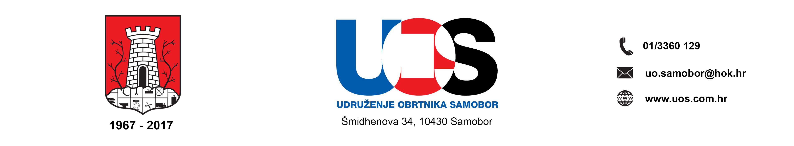

asociacion juvenil intercambia (spain)
Intercambia is a youth organization created by and for young people. Our main activities are based on intercultural learning, by using a non-formal education and youth program actions in order to encourage the youth participation in the international context, so abolishing the barriers between countries, reducing the racism and promoting the tolerance between different cultures. Our organization wants to encourage youth initiatives by young people - we support them by providing information, tools, and training to help them get their goals.
www.europaerestu.eu

youthfully yours (slovakia)
Non-governmental organization Youthfully Yours SR was established in 13.1.2015 as civil society and registered by Ministry of Interior of the Slovak Republic. Its main focus lies on enhancement of active citizenship, social integration and intercultural dialogue. Our team is full of innovative spirit that deeply desires to encourage young people to study, work or volunteer aboard. We truly believe that these can significantly help to personal development of each young adult and international experience required this way is the right tool to deal with xenophobia and prejudices – still presented in our society.

info@youthfullyyours.sk

EURO SUD (ITALY)
EUROSUD is established in the small city of Triggiano. Close countryside and rural area around Bari. The organization is made up of number of experts with a goal to offer a support, help, services and counselling in the area of civil society and democratic institutions development, civil values, and non-formal education for all citizens (especially for young people). EUROSUD organizes events (round tables, debates, seminars and workshops) about activism, education, promotion and exchange regarding human rights, development of local, regional, European and international cooperation. EUROSUD especially promotes development of creativity, innovation, entrepreneurship and sustainable development (of civil society).

eurosudngo@gmail.com

YOUTH EURASIA (TURKEY)
Youth Eurasia is a nonprofit youth organisation established by Institute of Social Sciences of
Marmara University students in 2012 and declared it's independency in 2015 and now is actively developing youth work throughout country and welcoming youngsters and adults. The vision of the organisation is carry out studies on adults and youth in the fields of environment, ecology, social-cultural issues, youth rights, active citizenship, social inclusion and soft skills development for establishing solidarity, cooperation and integration on societies.

www.youtheurasia.org

contact person

Tamara Obradović
Project coordinator
uo.samobor@hok.hr

DISCLAIMER

This publication [communication] reflects the views only of the author, and the Commission or Agency for mobility and EU programs in Croatia cannot be held responsible for any use which may be made of the information contained therein.

