Volunteering Project in Italy
Project Title: Stars on blUE

Infopack for volunteers

Dear future volunteer,

ESC projects are a unique opportunity to be actively engaged and make the difference in a local context and community, developing solidarity among people but also open mindedness, communication and cooperation between different nations and cultures.
In this project you will work in a team of experienced staff in and have the opportunity to live new experiences, know new friends and work in an international team, working in the field of youth information, communication and promotion, project management and non-formal education.
We will support you to implement your own projects, cooperate with other volunteers from different countries and you will know our city – lively and rich of artistic works and monuments. We will know each other, our cultures, habits and traditions, language and lot of other things…

See you soon!

STUDIO PROGETTO Social Cooperative is now looking for one volunteer from Slovakia
See below more details!

COORDINATING AND HOSTING ORGANISATION

The coordinating and hosting organisation, “Studio Progetto” Social Cooperative, runs from 2012 EVS projects and regularly hosts volunteers. Till now, it has hosted 42 volunteers from EU and non-EU countries.
Studio Progetto is a non-profit organization founded in Valdagno (VI) in 1989. It is inspired by the principles of the World Cooperative Movement: mutuality, solidarity, democracy, involvement, balance and sharing of responsibilities, communitarian spirit and a balanced relation with the State and the Public Institutions. It pursues the general interest of the community toward human promotion and social integration of citizens, managing health, social and educational services and promoting entrepreneurial activities, aimed at providing employment for disadvantaged people.

OUR ACTIVITIES
Studio Progetto works in several areas:
• Minor and Youth Area: includes Youth Information Centres/Offices in the Vicenza province, addressed particularly to young people (13-30 years old). We also organize Summer Camps and Educational after-school Programs for children aged 6-14, mainly with a homework support program and re-creational activities. We also manage inclusion projects for migrants, hosting about 40 refugees in cooperation with local institutions.
• Health Area: includes Home Care services, a complex of social assistance services offered for elder people, the disabled and children, and Support services for Family Doctors, such as secretariat and nursing services in associated doctor’s offices.
• Disability Area: manages “No Problem” Office, a social-rehabilitative program for patients with brain shock and/or with acquired neurological disability. The main activities are data entry, copy shop, paper craftworks and music therapy workshops.
• Mental health Area: is composed by two daily centres for patients with mental disease and social outcomes: “La Lanterna” is a restoration lab of antique furniture, and “Il Faro” deals with biological horticulture and artistic workshop.
• Work integration Area: helps the work placement integration for people with social disadvantage. The main activities are cleaning, reastauring and clothes pattern making.

THE PROJECT

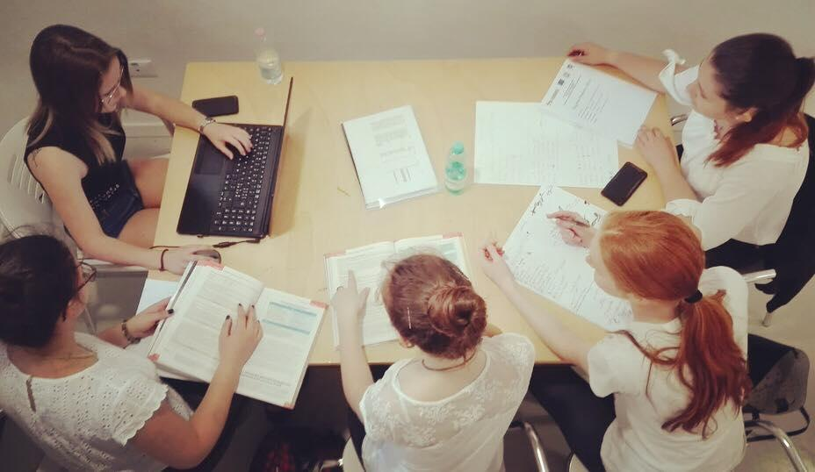

Through the project “Stars on blUE”, Studio Progetto will host 6 volunteers, 2 of them will be engaged in Vicenza.

The project pursues ESC specific aims. In brief:
- encouraging the sense of solidarity and tolerance among young people;
- increasing active citizenship and participation of young volunteers and local young people;
- promoting European Solidarity Corps and the mobility opportunities promoted by EU;
- increasing the sense of European citizenship among young people and citizens in general;
- stimulating the creativity and competence learning of young volunteers, who will cooperate with experienced staff and will be actively involved in the places they will operate, in order to increase their employability;
- facilitating intercultural dialogue in our territory;
- raising awareness on European issues;
- involve young people with minor opportunities, both volunteers and local youth.

This call is to candidates from Slovakia: we are looking for one volunteer who will be engaged in the Youth Information Center and Polo Giovani B55.

LOCATION

Youth Information Center and “Polo Giovani B55”

Link (Facebook): @ProGioVi – @InformagiovaniVicenza - @Bcinquantacinque
www.informagiovani.vi.it

Instagram: @progettogiovanivicenza

The volunteer will be engaged for 30-32 hours per week in 2 services of the Municipality of Vicenza for youth information, innovation and training.

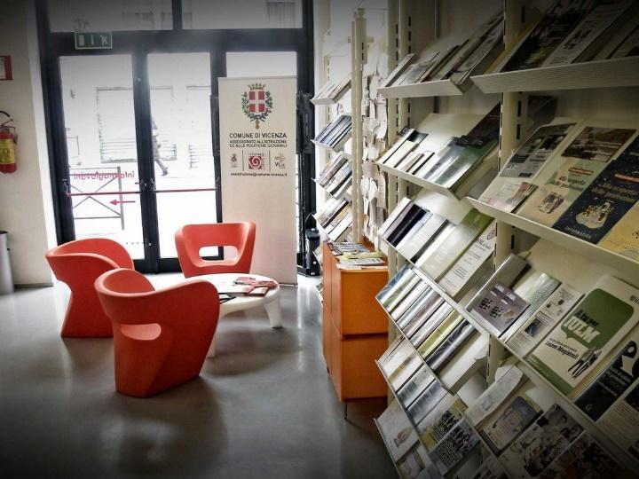
The Youth Information Centre of Vicenza works in the fields of youth information and youngsters involvement for the development of their active citizenship. It offers guidance about training and education, placement, mobility and volunteering activities, stimulating the participation of young people to social life. The daily activities consist in organising of paper and digital information and promoting events and training activities about guidance, mobility, volunteering, learning and training opportunities, that often take place also in the high schools of Vicenza.

POLO GIOVANI B55 is the place of innovation, professional training and new professions, with lot of spaces and rooms for lessons, workshops, training courses and so on. It is also the place of coordinating desks of “Progetto Giovani Vicenza”, that includes the 4 different services managed by “Il Mosaico”: Youth Information Office, Polo Giovani B55 and 2 Youth Centers.

The main purpose of all the 4 services are to prevent social hardship, school leaving and youth unemployment by giving information and increasing awareness about opportunities at the local and international level, but also about personal skills and potentialities, empowering young people to face the challenges they will run into and improving their individual and informal groups skills through participatory activities.

ACTIVITIES

The volunteer will be involved in the following activities

- Public relation - front office, mostly spreading information to young people about the opportunities offered by Erasmus+ Program
- Work with students in high schools (meetings, infodesk during schooltime...) giving basic information about Volunteering Projects and other opportunities (job, voluntarism, youth participation, etc.), but also about EU and European institutions
- Events organization
- Promotion and communication activities
- Support the staff in their daily work
- Rooms arrangement
- Involvement in European projects (i.e. youth exchanges)

The volunteer will have the opportunity to gain social competences, but also in the field of communication and project-management.
He/she will be actively involved in online and local promotion of the different activities run by all the 4 centers of Progetto Giovani Vicenza.

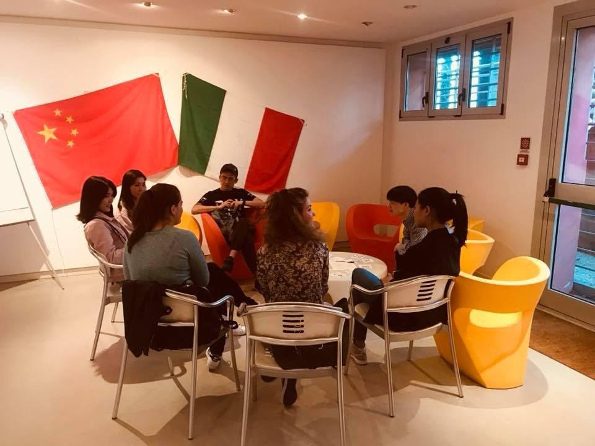
Beside this, volunteer, in cooperation with the other European volunteers, will be involved in addictional activities and their tasks will be:
- Participate to linguistic exchanges called “tandem”: with young people that are in Vicenza to study or work as interns, we successfully organise conversation groups or linguistic one-to-one exchanges in many languages, like French, German, Spanish, Chinese, English. Volunteers will be actively involved.
- Non-formal training session with all the volunteers hosted by “Studio Progetto”.
- Promote meeting and activities with the volunteers hosted by other organisation in Vicenza.

TIMETABLE (standard week – may be modified)
 | Mon | Tue | Wed | Thur | Fri
MORNING | 11.00 – 13.00  Staff meeting | 10.00 – 13.00  Youth Information Center | 8.30 – 10.30  Information and non formal education activities in schools | 10.00 – 13.00  Youth Information Center | 9.30 – 11.00  Group mentoring
 |  |  | 11.00 – 12.00  Italian language course |  | 11.00 – 12.00  Think tank – developing ideas together
AFTERNOON | 15.00 – 18.30  Polo Giovani B55 | 15.00 – 18.30  Polo Giovani B55 | 17.30 – 21.00  Polo Giovani B55 | 17.30 – 21.00  Polo Giovani B55 | 15.30 – 18.30  Youth Information Center
EVENING | 19.30 – 21.00  Polo Giovani B55

The team you will work with is composed by education professionals, youth workers, trainers, psychologists, project managers. These professionals are well known at the local level and gained years of relevant experience in the field of children and youth education and information.
Currently, there is also a volunteer from Armenia that is more engaged in two Youth Centers of the city. The 2 volunteers in Vicenza will run some activities together and will have the opportunity to propose ideas using their formal/non formal competences. They will cooperate with the team to conceive and manage weekly activities, giving support to promote and plan them, participating to team meetings with the other youth workers of the structure they work in and the coordinator.
They will also have a the possibility to take a special time with the tutors to think and develop new projects and ideas for the young people and children of Vicenza, plan events and activities that will be open to the whole local community and create with young people concrete tools that will be useful to Vicenza Youth Project (i.e. videos or promotion materials).

THE CITY

www.comune.vicenza.it

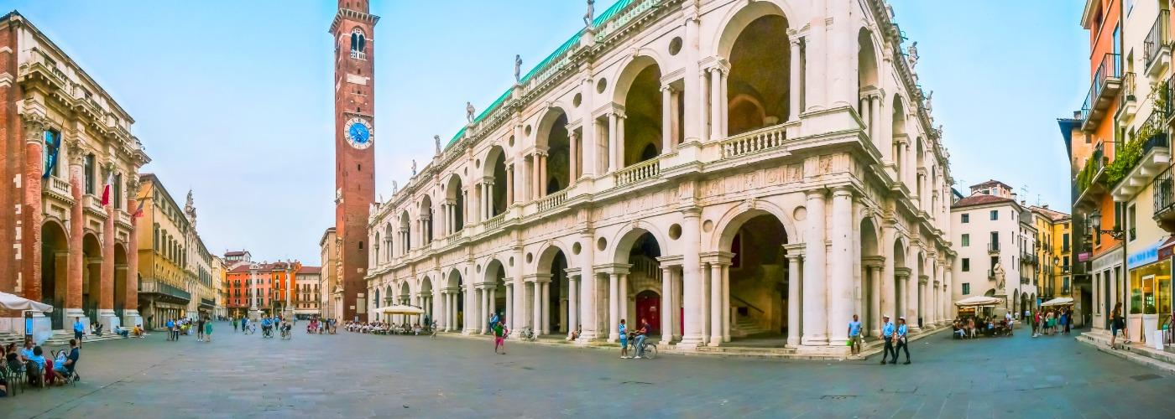

Vicenza proudly exhibits the signs of its Roman background and its 'unique appearance,' largely owing to the work of influential sixteenth-century architect Andrea Palladio, has led to the town's designation as a UNESCO World Heritage Site: City of Vicenza and the Palladian Villas of the Veneto. Today Vicenza is, in fact, one of Italy's cities with the highest number of monumental complexes compared to its extension. This makes it a real unexpected jewel to those visitors who take a walk in the old town centre. But Vicenza is also economy, industry and handicrafts, production and export. Vicenza has an active role in building the “Veneto model” which enabled the region to reach a good level of well-being and social ease, which was unhoped for until a few decades ago. Right next to large groups, stand out medium-sized, small and very small companies, endowed with a lively spirit of enterprise, production flexibility, technical innovation and a strong export orientation. Veneto is a striking example of what in the sixties was called "Italian economic miracle". Until the mid-fifties it was a land of peasants, poverty and migration, plagued by constant floods, while later on it became one of the leading Italian industrial regional economies.
From the geographical point of view, from the '60s the sudden growth of industries and economic activities inexorably changed the Po valley landscape where the city is located. Before, Palladio villas were surrounded by huge cultivated fields and vineyards. Nowadays the fields has mostly left space to houses, industries, warehouses, shopping centers. But the neighbourhood is an ever-changing landscape of mountains, valleys, water courses, art cities, and food and wine itineraries offering evocative landscapes.
Vicenza is a medium-sized town, with a population of 110,000. While there is a quite diffused wellbeing among the population, the number of citizens with chronic problems have increased, due to the economical crisis and problems, like unemployment.

ARE YOU THE RIGHT VOLUNTEER?

Profile of volunteer:
- age between 18-30 years old
- interested in youth issues
- willing to get involved in communicating with young people
- team spirit
- responsible, creative, curious, open-minded
- good competences in using computer, internet, social networks: communicative, graphic and promotional competences and abilities will be positively valued

Period: from September 2020 for 11 months
Deadline: 30/06/2020

If you are interested in becoming volunteer
please register on europa.eu/youth/solidarity and send your registration number to progettazione@studioprogetto.org
and in cc to
lara.lupato@studioprogetto.org

If you have questions or doubts don’t hesitate to contact us!

