ERASMUS + KA105 – YOUTH MOBILITY
LET’S COOK OUR HERITAGE
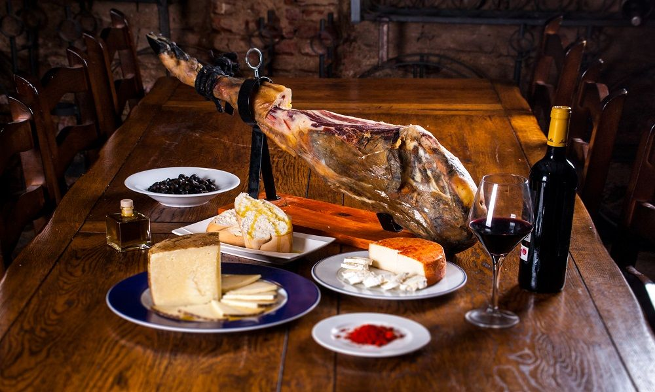

PROJECT DETAILS:
- WHAT: Youth Exchange entitled “Let’s Cook Our Heritage”
- WHERE: Losar de La Vera (Cáceres, Extremadura region, Spain)
- WHEN: From the 4th until 13th November 2020
- WHO: Workers in the field of youth, specialised in gastronomy, patrimony and cultural tourism.

ABOUT THE PROJECT:
La Vera Shire is a place with a strong heritage related to patrimony, history and gastronomy. For these reasons, professionals in the field of youth will be participating during 10 days through non-formal education in a training course which they will learn about gastronomic tradition and the cultural heritage of this cuisine.

Moreover, the inputs participants will receive, will allow them to foster other skills such as entrepreneurship, creativity, problem-solving, empathy and tolerance.

PROJECT OBJECTIVES:
- Develop the personal and professional growth of workers in the field of youth in relation with traditional and professional gastronomy
- Value the culture, patrimony and heritage that Europe possess thanks to its cultural gastronomy.
- Promote multiculturalism, knowledge and respect for different European traditions and cultures
- Foster entrepreneurship and economic opportunities through culture and heritage.
- Motivate youth workers and youngsters for active participation in cultural events and opportunities.
- Promotion of a more sustainable tourism through culture and gastronomy.

PARTICIPANTS
The eligible participants for this course will be workers in the field of youth aged over 18 years old. There will be a maximum of 6 participants per each country and they will be chosen according their social competences, interest in the topic and their linguistic competence in English.
On the other hand, the balance between men and women will be had into account in order to organise an equal and diverse mobility.

COUNTRIES & PARTNERS:
- Spain: Cooperation Network of the European Routes of Emperor Charles V
- Slovakia: Youthfully Yours SK
- Italy: Associazione Atrium
- Lativa: Sia “Hotel School” Viesnicu biznesa koledza
- Bulgaria: Ti Mozhesh Li
- Cyprus: Cyprus Food and Nutrition Museum

JOURNEY

Volunteers will arrive in Spain from their respective countries by plane.
The closest airport and with more flight connections is Madrid Airport which is 245 kilometres away.

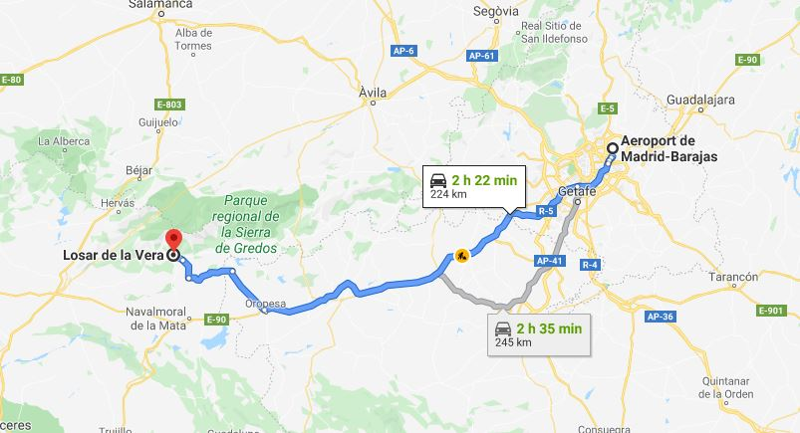

The second option is Seville airport is 385 kilometres away and it has not as many connection flights as Madrid airport.
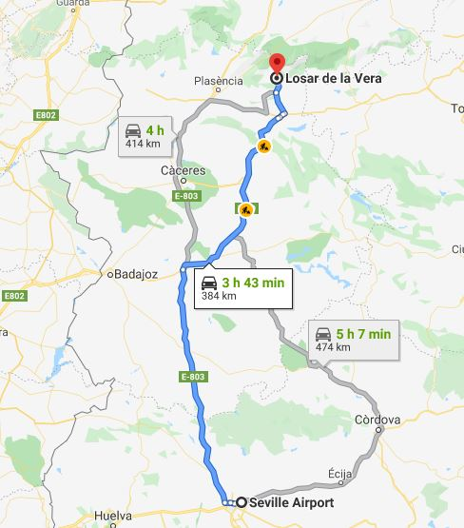

ACCOMODATION
The accommodation for participants will take place in the “Vadillo” Hostel, located in the centre of the town of Losar de la Vera.
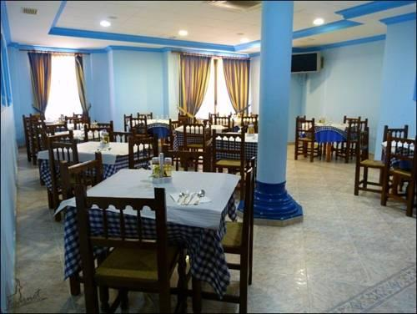
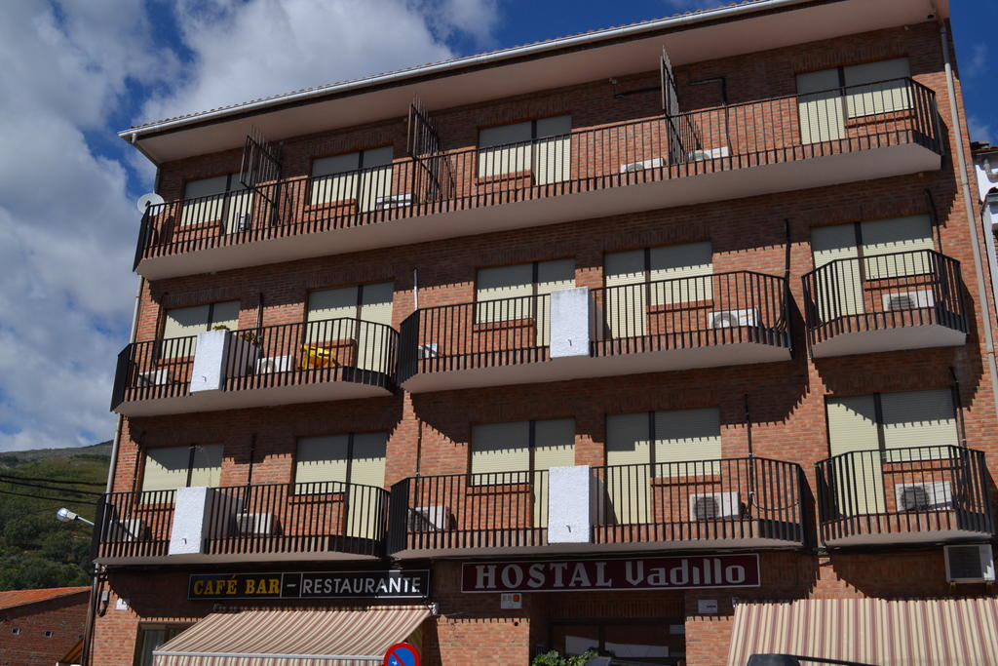
Ttt

The distance between Hostel Vadillo and the facilities for the activities is around 400 metres and is less than 5 minutes walking.
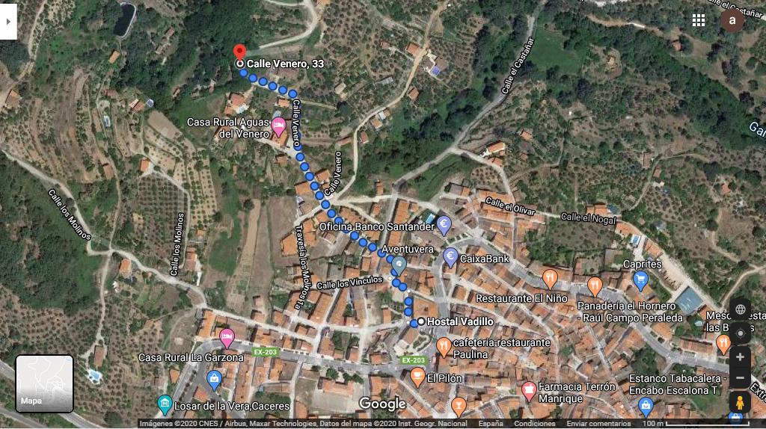

LOCATION OF THE ACTIVITIES
As mentioned previously, the mobility will take place in Losar de la Vera, a town located in Extremadura. It has been selected the “Venero” facilities for the realization of the activities. These facilities are equipped with:
- Kitchen
- Dining Hall
- Bathrooms and changing rooms
- Camp zone for modern tents
- Leisure zones
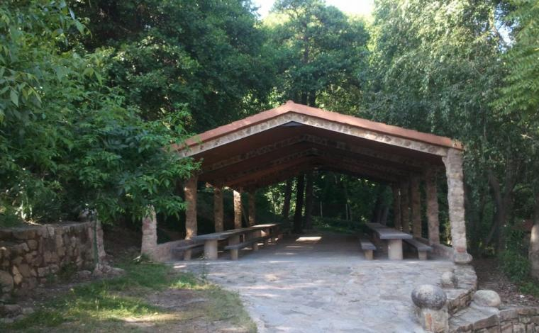
- Multi-use rooms and areas.
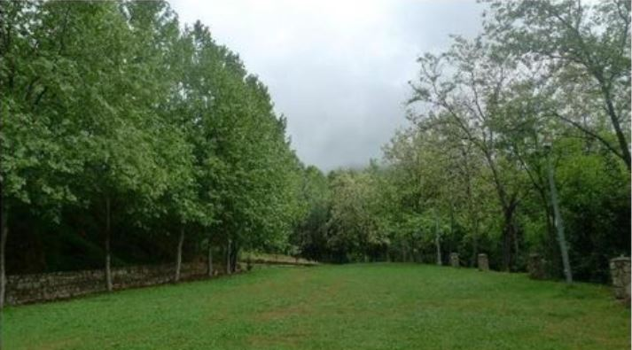

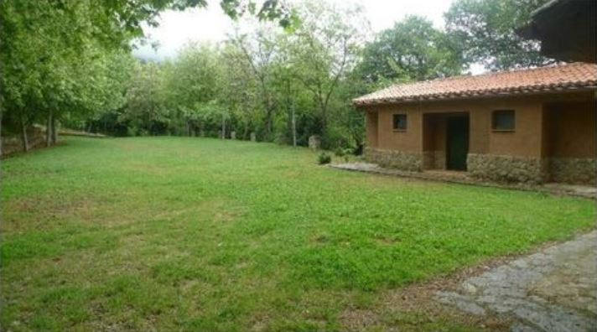
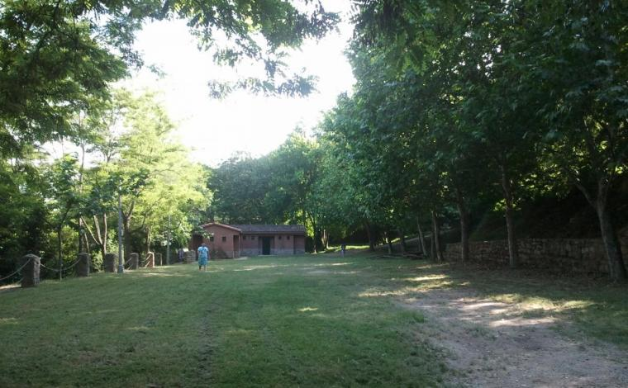
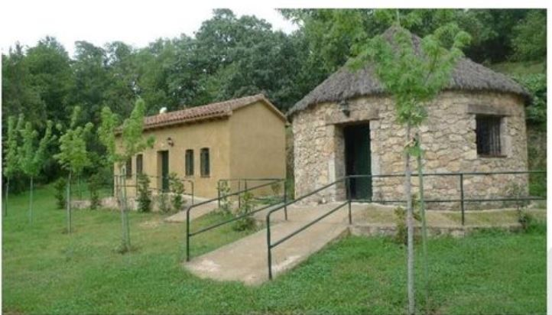
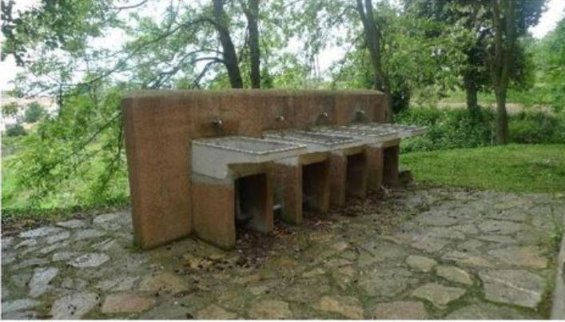

Having all these amenities, those volunteers eager to participate in these exchange will have the appropriate environment to foster their personal skills and perform the activities planned in the exchange.

LOSAR DE LA VERA
Losar de la Vera is a town located in the west part of Spain, in the Extremadura region.
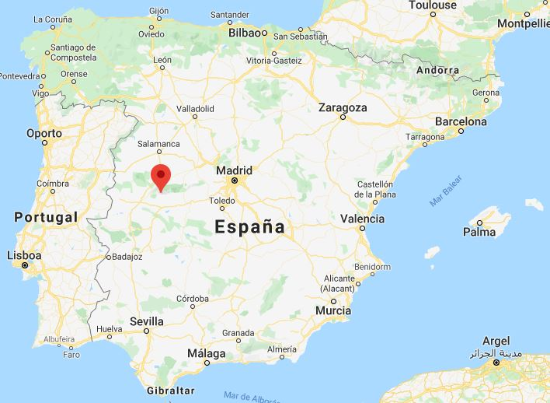

Losar de la Vera, and the municipalities around it, is an attractive area for cultural tourism and it is close to natural environments as well. It is a location with a strong gastronomic heritage and tradition, where participants of this course will learn and enjoy about history, patrimony, tradition and cuisine.

